INFORMATION BULLETIN

ALLIANCE HOCKEY
71 Albert Street
Stratford, Ontario N5A 3K2
Tel (519) 273-7209
Fax (519) 273-2114
www.alliancehockey.com
alliance@alliancehockey.com

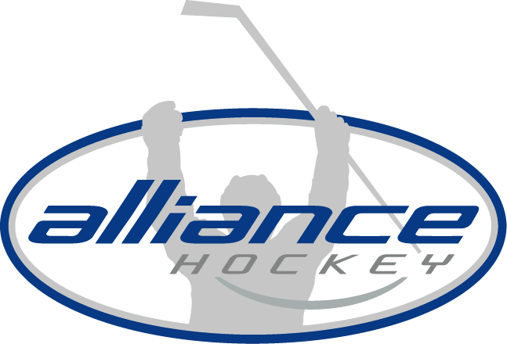

Number: 2019 – 02

TO: ALLIANCE Hockey
DATE: April 26, 2019
RE: Non-Residential Player Movement Inquiries

ALLIANCE Hockey registration and participation for Representative and Minor Development Programming follows the Hockey Canada Residency Rule. You play where you reside. Non-Residential Player inquiries will only be dealt with as a result of a Member Association not being able to field a team.

If ALLIANCE Hockey Member Associations teams are short of players or are contemplating folding programs the ALLIANCE Hockey Office must be notified immediately as they may be able to assist with players from other Member Associations. If a team is unsuccessful and does fold, any movement of players must follow procedure as outlined in this bulletin.

- ALLIANCE Hockey players or parents inquiring about alternative ALLIANCE Hockey or OMHA programming including Goaltender Assistance must be directed to the ALLIANCE Hockey Office or the Regional Vice President. Under no circumstances are ALLIANCE Hockey Member Associations to direct players to alternative programming in the Alliance or OMHA. Players who did not attend their home association try-outs will not be considered for movement to another Minor Hockey Association team.

- OMHA players or parents inquiring about ALLIANCE Hockey programming which also includes Goaltender Assistance must be directed back to their OMHA center or OMHA Regional Director.

Regards,
Tony Martindale
Executive Director, ALLIANCE Hockey

